**Statement of User Requirements for**

Inventory and

Annual Procurement Plan

Stock Availability Monitoring System

1. **Introduction**

This User Requirements aims to specify, enumerate and describe the features and functionalities that the client, the UPVTC Supply and Property Services Office (SPSO) expects from the final output of the software developers during their CMSC 198 (Practicum) this April-May 2011. This document will serve as (1) basis for the design of the Web-based system, (2) reference for the developers and (3) guide in assessing the quality of the developers’ final output.

1. **Procedures**

The SPSO requests for a Web-based application that will automate two procedures to wit; (a) Inventory and (b) Annual Procurement Plan (APP) Stock Availability Monitoring.

1. Inventory

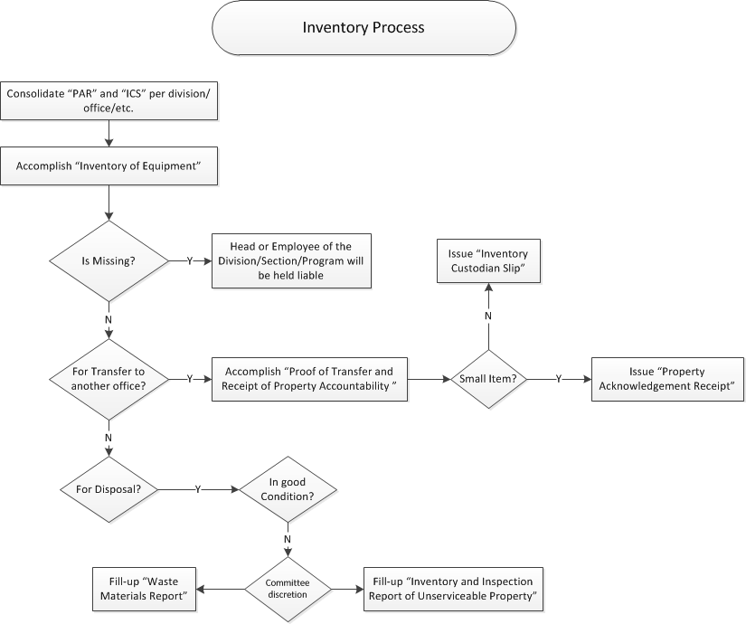

Annually, the Supplies and Property Office (SPSO) conducts an inventory for each of division/section/program of UPVTC (see Annex A - List of Division/Section/Program). Using the *Property Acknowledgement Receipts (PAR)* and the *Inventory Custodian Slips (ICS)* of each office, the SPSO accomplishes the *Inventory of Equipment.* The office then assesses the condition of each of the items.

In case an item is reported missing, the department head of its designated office or the certain employee to which the item was assigned will be held liable. If [an] item/s is/are to be transferred to another office, the *Proof of Transfer and Receipt of Proper Accountability* is accomplished wherein the source and destination offices are stated. If the item *for transfer* is small (see List of Tangible Assets That May Be Considered as Inventories), the office issues the *ICS* else, *PAR* is issued.

If [an] item/s is/are deemed *for disposal*, it is checked if it is in good condition or not. If it is, the Disposal Committee fills up the *Inventory and Inspection Report of Unserviceable Property*. If not, the same committee fills-up the *Waste Materials Report.*

1. Annual Procurement Plan (APP) Stock Availability Monitoring

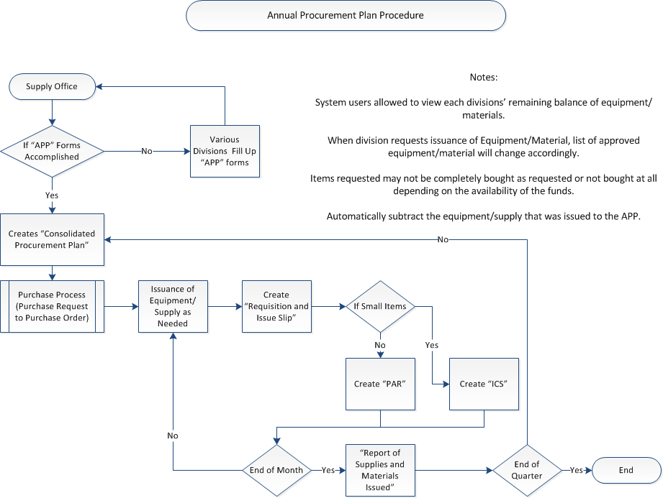

Yearly, the SPSO distributes the *Annual Procurement Plan (APP)* Forms to all offices (see Annex A). The office then consolidates these forms to the *Consolidated APP* form per quarter. When an office requests for [an] item/s, the SPSO accomplishes the *Requisition and Issue Slip* wherein the items requested are enumerated. Once the requesting office receives the item, the SPSO issues either *PAR* or *ICS* depending on the type of the item. At the end of each month, the office then fills-up the *Report of Supplies and Materials Issued*. The items are then deducted from the available stocks from the *APP* of the requesting office. By the end of each quarter, the SPSO monitors the available stocks of each office (see Annex A).

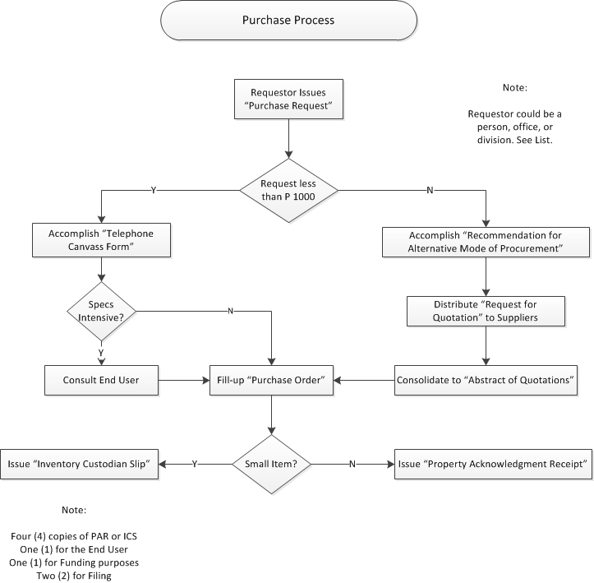

The Purchase Process, an aggregate component of the APP Procedure, starts when an office (see Annex A) submits to the SPSO [a] *Purchase Request*/*s (PR)*. If the total amount of the request is less than one thousand pesos (P1000.00), the office will then accomplish the *Telephone Canvass Form* wherein three (3) suppliers will be called for the price of certain items. In the event that less than three suppliers are available in the immediate area, the SPSO will determine if the item will be canvassed from outside suppliers. If the office deems the item/s to be not *specs intensive (e.g. office supplies)*, they will accomplish the *Purchase Order* directly – choosing the supplier that sells the item/s for the least amount but still meeting the set specifications. Otherwise, they will first consult the end-user.

If the total amount of the *PR* equals/exceeds one thousand pesos, the SPSO accomplishes the *Recommendation for Alternative Mode of Procurement (RAMP).* Once the *RAMP* is approved by the Dean, the office then distributes *Request for Quotation (RQ)* to identified suppliers. The *RQs* are then consolidated to the *Abstract of Quotations*. After which, the *PO* is accomplished wherein the supplier that sells the item/s for the least amount but still meeting the set specifications is chosen.

After the *PO* has been accomplished, the SPSO decides whether the item/s in the *PO* is small (see List of Tangible Assets That May Be Considered as Inventories) or not. If it is, the office issues the *ICS* else, *PAR* is issued.

1. **Specifications/Requirements**
2. Restrict data access to SPSO personnel only by providing a username and password.
3. Allow the user to import files in Microsoft Excel (.xls) format.
4. Allow the user to generate, print and/or save reports to Microsoft Excel (.xls) or Adobe Portable Document Format (.pdf).
5. Provide faster data retrieval through search functionality.
6. Allow automated completion of forms.
7. **Assumptions, Principles, and Other Constraints**
8. The Philippine peso will be used to report the financial transactions of the SPSO.
9. The Inventory and Annual Procurement Plan Stock Availability Monitoring (IAPPSAM) System is intended to be a web application.
10. The IAPPSAM System will be used only by the SPSO personnel.
11. The forms used in the transactions will be provided and should be followed.
12. Users are assumed to be computer literate and must have basic knowledge on the following computer software:
    1. Adobe Reader
    2. Microsoft Excel
13. Users must have a basic knowledge in using the internet.

**Manual vs. Automated Procedure**

|  |  |  |
| --- | --- | --- |
| ***Process to be done*** | ***Manual Procedure*** | ***Automated Procedure*** |
| *Input the data* | Personnel manually fills-up different types of forms for certain conditions | As for the recording of data, the IAPPSAM application grants two options.  *Option 1:*  user can input using the application  *Option 2:*  import a Microsoft Excel(.xls) file to the application |
| *Creating report* | User manually manipulates data to come up with a report | IAPPSAM provides a variety of choices in terms of report generation. The generated report, then, could be saved/printed in the following format:  a. Microsoft Excel (.xls) format  b. PDF (.pdf) format |
| *Viewing/Retrieval of Files* | User manually searches files which would take considerable time and effort | IAPPSAM gives the user freedom to speedily search files may it be specific or general. The application also provides backup and recovery of the database. |
| *Editing files* | User edit files in excel records and this is risky because anyone can edit records | Only authorized personnel from the Supply Office can edit a file since the IAPPSAM is protected by identity authentication and a system log monitors editing of file/s |

**ANNEX A**

**Supply and Property Services Office**

**List of Division/Section/Program**

Office/Division:

1. Division of Humanities
2. Division of Management
3. DNSM
4. Division of Social Sciences
5. Office of the Dean
6. Office of the Associate Dean
7. Accounting Office
8. Cash Office
9. Office of the College Secretary
10. HRDO
11. Office of Student Affairs
12. Clinic
13. SPSO
14. Security Services
15. CDMO
16. COA
17. SAO Office
18. System Administration

Individual Records:

1. Auxiliary Services
2. GDP
3. Library
4. TLRC
5. LSHC
6. OASH
7. OCEP
8. TILC
9. Student Council
10. UP-VISTA
11. SWF
12. ROTC
13. CWTS